### Creation Of Fields For The Department Object

**Creation of fields for the Department object:**

1. Click the gear icon and select Setup. This launches Setup in a new tab.
2. Click the Object Manager tab next to Home.
3. Select **Department**
4. Select Fields & Relationships from the left navigation
5. Click New
6. Select the Text as the Data Type, click Next.
7. For Field Label, enter Department Code and enter 5 in Length.
8. Click Next, Next, then Save & New.
9. Follow above steps and create two more Text type field - District & State.
10. Also, Provide Length 40 for both District and State field.
11. Create URL type field & give “Schoolwebsite” as the field label.

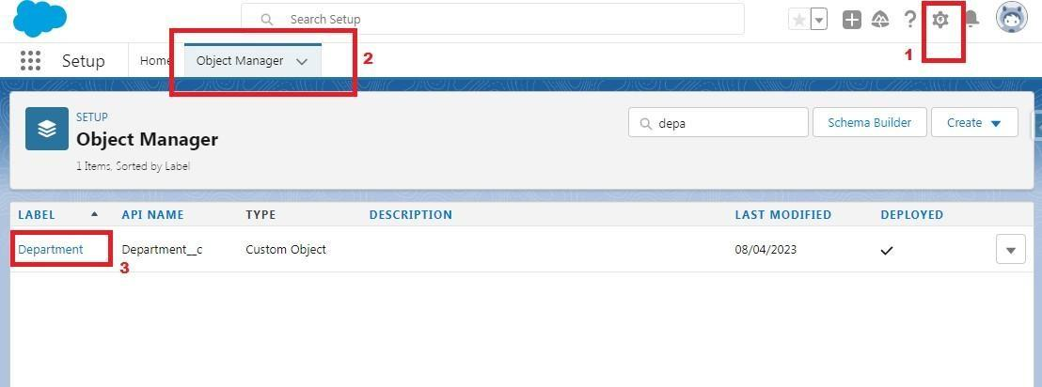

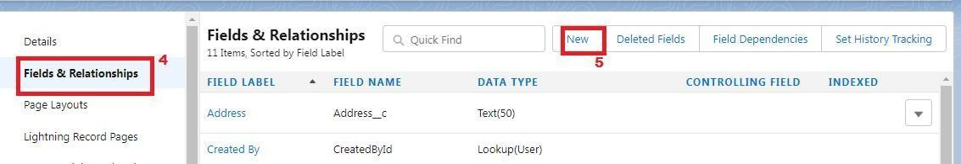

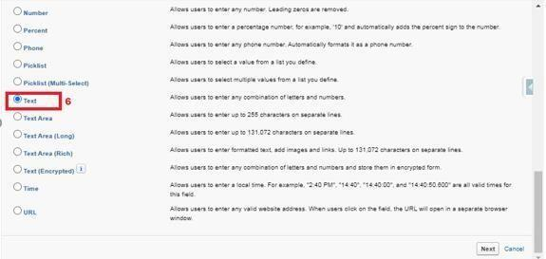

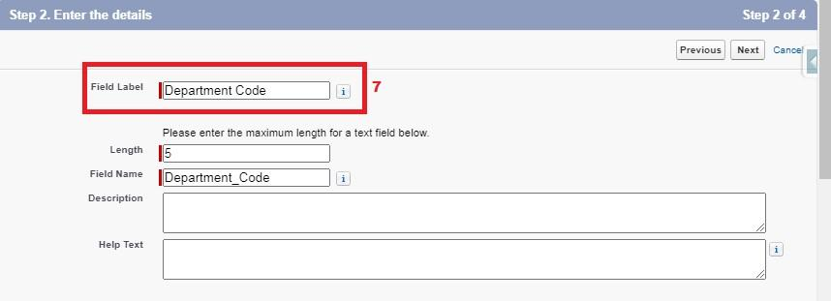

Now let's create the other fields and **we must choose the data types of the fields carefully** . Let’s  have a look  at it.

 These are fields and their data types we need to create make them one by one –

**NOTE** - See activity 2, 3, 4 below to create lookup field, Roll-up summary field & Picklist field

|  |  |  |
| --- | --- | --- |
|  | **Object Name Field Name** | **Data Type** |
| 1. | Employee Detail- Date of Birth | Date |
|  | Gender | Picklist (Male, Female) |
|  | Department | Lookup (Department)(See activity 2 to create lookup) |
|  | Employee Id | Text (Length - 12) |
| 2. | Expense- | Employee Lookup (Employee Detail) |

Total Item                                 Rollup summary (Expense Item)

 Travel approval                       Master Detail ( Travel approval)

|  |  |  |  |
| --- | --- | --- | --- |
| 3. | Expense Item - | Expense | Master Detail (Expense) |
|  |  | Expense  Type | Pick  List  (Values  are-  Transport,  Hotel,  Meal,  Others)  Amount  Currency |

4. Travel Approval- Employee Name

 Lookup (Employee Detail) Department  Lookup (Department)

Destination state Text (Length – 40) and make it as a required.

Purpose of trip Text (Length – 256)

Trip start date Date

Trip End date Date

 Out-of-state                           Checkbox

 Amount                                 Currency (Length-10)

Status Picklist (Values are- Approved, Rejected)

 Total Expenses                       Roll-up Summary (sum>Expense>amount) 

**NOTE** - Make Trip Start Date and Trip End Date fieldrequired when making these field